Using Proxy to connect the frontend and backend:

React frontned:

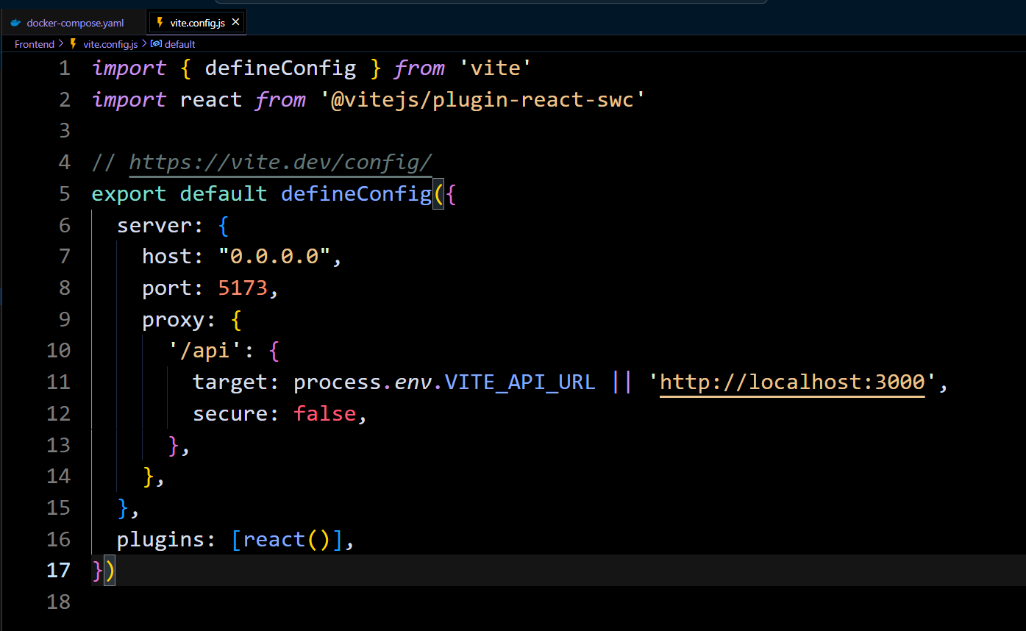

Then we need to use this docker-compose.yaml file

version: "3.8"

services:

  backend:

    build: ./Backend

    container_name: backend

    ports:

      - "3000:3000"

    environment:

      - PORT=3000

    networks:

      - mern-net

  frontend:

    build: ./Frontend

    container_name: frontend

    ports:

      - "5173:5173"

    environment:

      - VITE_API_URL=http://backend:3000

    networks:

      - mern-net

networks:

  mern-net:

    driver: bridge

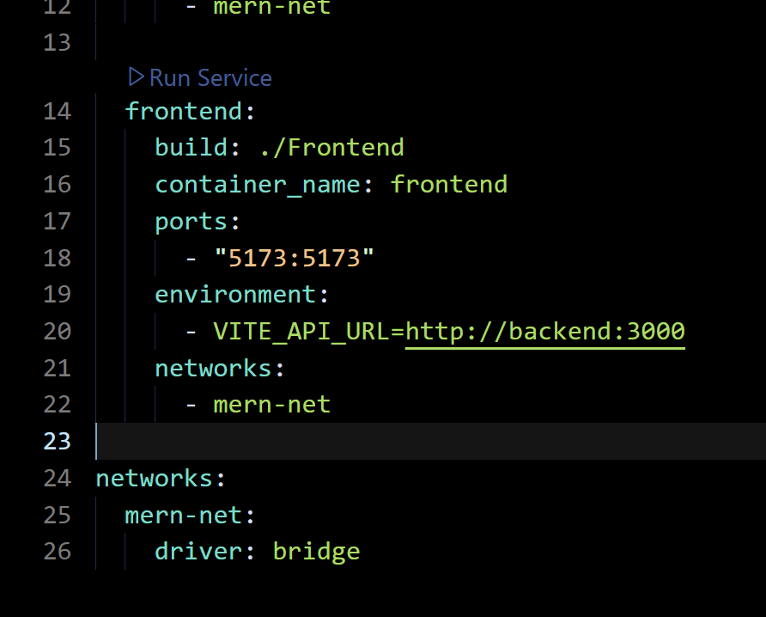

With out using proxy frontend and backend connection: